40. RBAC Policy DSL Compiler with Static Security & Privilege Escalation Detection

Course Name: Compiler Design
Course Code: CS1202
Name: Pinikeshi Meghana
Roll No: 24CSB0A54
Sec: CSE-A
Document Details: Week 4 Deliverables

Week 4 – Compiler Architecture & System Design
1. Introduction
Week 4 focuses on the system design of the RBAC Policy DSL Compiler. The main objective is to define the architecture, show how modules interact, and justify the tools and technologies chosen for implementation. This stage ensures a clear understanding of the system flow and prepares for coding the compiler.
2. Compiler Architecture Diagram

Purpose:
The Compiler Architecture Diagram visually represents the main components of the RBAC Policy DSL Compiler and the flow of data between them. It helps understand how RBAC policies are parsed, analyzed, and reported.
Components:
- RBAC Policy Input (DSL) – The policy file containing roles, permissions, and users.
- Lexical Analyzer – Converts the DSL input into tokens.
- Parser – Generates an Abstract Syntax Tree (AST) from tokens.
- Semantic Analyzer – Performs semantic validation, checks role hierarchies, and detects conflicts.
- Static Security Analyzer – Detects privilege escalation, redundant permissions, and over-privileged roles.
- Security Report Generator – Produces human-readable and explainable reports of detected issues.

Data Flow:
- Input → Lexical Analyzer → Parser → Semantic Analyzer → Static Security Analyzer → Security Report Generator

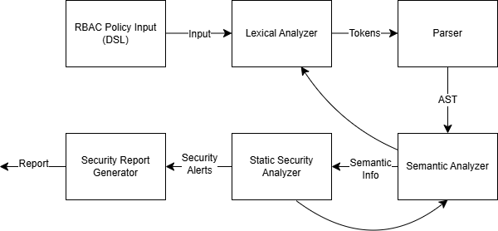
3. Module Interaction Diagram

Purpose:
The Module Interaction Diagram shows how the different components communicate with each other, highlighting data dependencies and the mapping of security threats to analysis modules.

Interactions:

Source Module | Target Module | Data / Purpose
Lexical Analyzer | Parser | Tokens
Parser | Semantic Analyzer | AST
Semantic Analyzer | Static Security Analyzer | Role hierarchy & permission info
Semantic Analyzer | Security Report Generator | Detected conflicts, over-privileged roles
Static Security Analyzer | Security Report Generator | Privilege escalation, redundant permissions

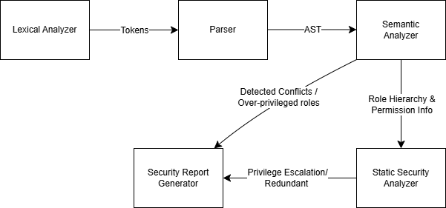

4. Tool and Technology Justification

Tool / Technology | Purpose | Justification
Python 3.x | Implementation language | Easy syntax, strong library support, dynamic typing, and object-oriented programming for compiler construction
PLY / ANTLR (Python version) | DSL parsing | Efficient lexical analysis, parsing, and AST generation in Python
draw.io | Diagram design | Easy creation of architecture and interaction diagrams
pip / virtualenv | Dependency management | Isolated Python environment and easy package installation
Git & GitHub | Version control | Tracks changes, supports collaboration, and submission
unittest / pytest | Testing | Unit testing of compiler modules ensures correctness

Justification:
Python provides a flexible and readable environment for building a DSL compiler. Libraries like PLY or ANTLR for Python handle parsing efficiently. Using version control, virtual environments, and testing frameworks ensures smooth development, reproducibility, and maintainability.

